# Internet of Things Solution for Asia Pacific College’s Facility Management System

Project Documentation Submitted

To the Faculty of School of

Computing and Information Technologies

Of

Asia Pacific College

In Partial Fulfillment of the Requirements for the subject

Introduction to System Development

By Marco Theo A. Butalid, Ivan Jasper U. Evangelista, John Matthew B. Fonacier, Luis Ginno Mabaquiao

**ASIA PACIFIC COLLEGE**

# Approval Sheet

Internet of Things Solution for Asia Pacific College’s Facility Management System

Prepared and Submitted by: Marco Theo A. Butalid, Ivan Jasper U. Evangelista,

John Matthew B. Fonacier  
Luis Ginno Mabaquiao

In Partial Fulfilment of the Requirements for the Degree of

Bachelor of Science in

Examined and Recommended for Acceptance and Approval for Research/Capstone Presentation

___________________________

Adviser

Panel of Judges

___________________________

Chairperson

Panel Members

___________________________ ___________________________

Panel Member Panel Member

Acceptance and Approved in partial fulfillment of the requirements for the degree of Bachelor of Science

_______________________________

Executive Director

School of Computing and Information Technologies

Table of Contents

Internet of Things Solution for Asia Pacific College’s Facility Management System 1

Approval Sheet 2

Abstract 6

List of Figures, List of Tables, List of Notations 7

I. Introduction 9

1.1 Project Context 9

1.1.1 Brief History of Facility Management 10

1.2 Purpose and Description 15

1.3 Objectives 16

1.4 Scope and Limitations 17

II. Related Literature 18

2.1 Meeting Room Monitoring 18

2.2 Konica Minolta Laboratory Europe (KMLE) Solution 19

2.3 Smart Meeting Rooms – Intel IoT 19

2.4 Conference Room Truth Serum 19

2.5 Meeting Room Booking System (MBRS) 20

2.6 Open Source Hassle-Free Booking System for Schools 20

2.7 One Space 21

2.8 Synthesis 21

III. Technical Background 22

3.1 Facility Management 22

3.2 Integrated Facility Management 23

3.3 Internet of Things 23

3.4 Intelligent Enterprise 24

3.5 Living Services 25

3.6 IoT Big Data Platforms 25

3.7 Machine Learning 26

3.8 Artificial Intelligence 27

3.9 Signal Processing 27

3.10 Cognitive Computing 28

IV. Design and Methodology 29

4.1 Requirements Analysis 29

4.1.1 Event Table 29

4.2 Requirements Documentation 31

4.2.1 Use Case Full Description 31

4.2.1.1 Provide class schedules 31

4.2.1.2 Operation of facilities 32

4.2.1.3 Professor reserves an additional facility 33

4.2.1.4 Activates the facilities in a room 34

4.2.1.5 Deactivates the air conditioner, lights, computers, and projectors 35

4.2.1.6 Facility sends feedback 36

4.2.1.7 Deployment of New Class Schedules 37

4.3 Gap Analysis/Needs Assessment 38

4.4 Design of Software, Systems, Product, and/or Processes 39

4.4.1 Login Page 39

4.4.2 Home Page 40

4.4.3 Create Report 41

4.4.4 Reserve Equipment 42

4.4.5 Admin User 43

4.4.6 Sample Layout of IOT 44

4.5 Development and Testing, where applicable 45

4.6 Description of the Prototype, where applicable 45

4.7 Implementation Plan (Infrastructure/Deployment) where needed 46

4.8 Implementation Results, where applicable 46

4.9 Include discussion on conceptual design/system architecture/ block diagrams and algorithms 46

V. Results and Discussion 46

VI. Conclusions and Recommendations 46

VII. Appendices 47

7.1 Use Case Diagram 47

7.1.1 Operation of facility 47

7.1.2 Reporting and/or reservation of a facility by professor 48

7.2 Context Diagram 49

7.2.1 Data Flow Diagram Level 0 50

7.2.2 Data Flow Diagram Level 1 51

7.3 Entity Relationship Diagram 52

7.4 Data Dictionary 53

7.4.1 it_equipment 53

7.4.2 it_equipment_type 54

7.4.3 PROFESSOR 54

7.4.4 refSubjectOfferingDtl 54

7.4.5 FACILITY 55

7.4.6 CLASS_STATUS 56

7.4.7 REPORTS 56

7.5 Activity Diagram 58

7.5.1 Facility Management System 58

7.6 System Sequence Diagram 59

7.6.1 Operation of facilities 59

7.6.2 Professor’s report 59

7.6.3 Professor’s reservation 60

7.7 Object Diagram 60

7.8 Class Diagram 61

# Abstract

Asia Pacific College (APC) is manually operating its air conditioners, lights, and computers in each of the room and is done with the help of the roamers under the Security Department. The use of these facilities follows the schedule of the students provided by the registrar and the reservations of different rooms for different activities on a first come, first served basis. The reservation is done through the receptionist who is stationed on the 4th floor that handles all the reservations made by the members of its organization, Information Technology Resource Office (ITRO) for the computer labs, 7th floor for discussion room B and C, Audio Visual Room (AVR) and Game Library in the library, Engineering and Sciences Laboratory handles the reservation for all of the 8th floor’s equipment and facilities, while the building administration that is located at the 10th floor is responsible for all the reservations made by outsiders, but mainly focusing on Multi-Purpose Hall (MPH), Auditorium, Parking, and Cafeteria for extracurricular activities.

On a regular class schedule and reservation, the air conditioner in a room is turned on a few minutes before the schedule starts, and is turned off depending on the schedule provided or the time it is over. The roamers under the Security Department, namely, Sky One and Sky Two who are responsible for the ground floor up to the 5th floor, and the 6th floor up to the 12th floor, respectively. They are also responsible for checking the attendance of the professors during different time periods to see if the professor was there in their class, and if the professor consumed most of the time in the schedule provided or had an early dismissal. The presence of the professor is the basis whether the guard is to turn of the facilities in a room or not, regardless of the room type.

# List of Figures, List of Tables, List of Notations

List of Figures

I.

1.1 Future of Facility Management Conclusion

1.2 Reservation clerk – Scope of Responsibility

II.

2.1 Synthesis

IV.

4.1 Requirements Analysis

4.1.1 Event Table

4.2 Requirements Documentation

4.2.1 Use Case Full Description

4.2.1.1 Provide class schedules

4.2.1.2 Operation of facilities

4.2.1.3 Professor reserves an additional facility

4.2.1.4 Activates the facilities in a room

4.2.1.5 Deactivates the air conditioner, lights, computers, and projectors

4.2.1.6 Facility sends feedback

4.2.1.7 Deployment of New Class Schedules

4.3 Gap Analysis/Needs Assessment

4.4 Sample Layout of Prototype

VII.

7.1 Use Case Diagram

7.1.1 Operation of facility

7.1.2 Reporting and/or reservation of a facility by professor

7.1.3 Inside Reservee

7.2 Context Diagram

7.2.1 Data Flow Diagram Level 0

7.2.2 Data Flow Diagram Level 1

7.3 Entity Relationship Diagram

7.4 Data Dictionary

7.4.1 it_equipment

7.4.2 it_equipment_type

7.4.3 PROFESSOR

7.4.4 refSubjectOfferingDtl

7.4.5 FACILITY

7.4.6 CLASS_STATUS

7.4.7 REPORTS

7.5 Activity Diagram

7.5.1 Facility Management System

7.6 System Sequence Diagram

7.6.1 Operation of facilities

7.6.2 Professor’s report

7.6.3 Professor’s reservation

7.7 Object Diagram

7.8 Class Diagram

# Introduction

## Project Context

M. K. Kurdi, A.H. Abdul-Tharim, N. Jaffar, M.S. Azli, M.N. Shuib, A.M. Ab-Wahid. (2011). Outsourcing in Facilities Management - A Literature Review. Retrieved from: <https://ac.els-cdn.com/S1877705811029961/1-s2.0-S1877705811029961-main.pdf?_tid=3d64a51f-1f7a-48c1-bfb2-039ee8d8aada&acdnat=1531608628_21a7ab441a4f7acc6fefdf813935dcb0>. “Most buildings nowadays are still practicing conventional facilities management which includes a small organization or team in one department,” similar to APC, but facilities are operated by specific people in different departments, focusing on satisfying its business needs and reducing utilities expenses at bare minimum. Despite the efforts, it is most of the time left for naught, for there are cases when the facilities are left turned on or still operating because of factors that are not considered by the person in charge. For instance, a meeting was held in a room, the standard procedures would be turning on the facilities that would be of use to satisfy that event before the meeting starts, the meeting was cancelled but the Sky One or Sky Two was unaware, from thereon out the facilities would continue to operate until the end of the scheduled meeting, wasting resources and space that would be best used for something else.

That is why the facilities management system is important. It is intended to maximize the use of its facilities up to its salvage values to reduce building life-cycle costs and maximize business profit. Different organizations follow the traditional approaches to facilities management, and that is outsourcing. This is done most of the time by businesses for them to focus on improving their Information Technology and management, however, it is not the best sourcing strategy under all circumstances. For large entities, it is recommended that they outsource facilities management, because as the business expands, it will be more overwhelming for the company to handle such affairs. According to an article by MSL 2016, retrieved from: <https://msl-ltd.co.uk/about/>, “For smaller businesses to outsource facility management is just unnecessary cost for a business and should not be absorb in their budget”, but in fact it is not the case, it can help business save money in the long term, giving the company more time to focus on their actual business.

## Brief History of Facility Management

Throughout the years, facilities management has started with just maintaining and ensuring that the facilities work without regard for the overall effects to the organization, which is tolerable in smaller organizations as the number of facilities are not to be totally concerned about, but as the organization grows bigger, the effect starts to become substantial, as stated earlier, companies outsource facilities management services for the reason that the companies cannot be bothered by it. According to Rentokil, retrieved from: <https://www.rentokil.com/sector-> insights/facilities-management/history/, a business service in the 70s, facilities management started as a little more than a janitorial and caretaker service. It involves building maintenance and cleaning, but due to the cost of these services, businesses outsourced the building maintenance which involves non-core services such as lighting, heating and plumbing to facility management companies. Throughout the years the number of services by the facilities management companies have grown, in the 1990’s services such as property management, space planning, and relocation were added, and in the 2000s it included payroll and human services. These then were called “Integrated Facilities Services”, which later then called Integrated Facilities Management or IFM. According to Frost and Sullivan, “IFM is a method of consolidating many or all of your office’s services under one contract and management team. The intent is to streamline communication and make day-to-day operations easier to manage. Thus, ensuring you are increasing workplace productivity and workplace wellness amongst your team.” These are the list of definitions made by different authors since the last decade.

|  |  |
| --- | --- |
| Author | Definition |
| Nourse (1990) | FM unit is seldom aware of the overall corporate strategic planning - does not have a bottom-line emphasis. |
| Bernard (1996) | Defines facilities as "the premises and services required to accommodate and facilitate business activity". Bearing this in mind, to have any chance of being fully cost effective the management of facilities must directly embrace the three-generic cost centers which includes premises, support service and information technology. |
| Hinks and McNay (1999) | Common interpretations of the FM remit: maintenance management; space management and accommodation standards; project management for new-build and alternations; the general premises management of the building stock; and the administration of associated support services |
| Nutt (2000) | The primary function of FM is resource management, at strategic and operational levels of support. Generic types of resource management central to the FM function are the management of financial resources, physical resources, human resources, and the management of resource of information and knowledge |
| International Facility Management Association (IFMA) | Facility management is a profession that encompasses multiple disciplines to ensure functionality of the built environment by integrating people, place, process and technology. |
| IBM Watson Internet of Things | "Technology is changing how buildings are used - but it can also help you adapt your facilities management strategy to rapid change." |
| International Service Solutions (ISS) A/S | FM is a multifaceted discipline to ensure the functionality of the built environment by integrating people, place, process and technology. |
| Frost & Sullivan (2016) | The convergence of FM services, property management, and energy management (EM) is the key driver of the acceleration of service integration and growth in integrated facility management (IFM). |
| IBM Watson Internet of Things | "Technology is changing how buildings are used - but it can also help you adapt your facilities management strategy to rapid change." |

Different companies such as IBM Watson, ISS A/S and Frost and Sullivan, continually enhance their facilities management services through Internet of Things or IoT. IoT, is a system of interrelated computing devices that are embedded with unique identifiers and has the ability to transfer data to a network without the need for human-to-human or human-to-computer interaction. This technology is a revolution for the facilities. Imagine a simple air conditioner that collectively consumes massive amount of energy to be operated through a web or software interface. But regardless of whether it consumes a large amount of energy or not, literally anything that consumes electricity is crucial. If the facilities are left underutilized, then it is wasting energy and plummeting its lifespan.

According to IBM, retrieved from: <https://www.ibm.com/internet-of-things/business-solutions/facilities-management>, they have a complete workplace management solution that combines data from sensors and equipment with powerful analytics to optimize everything from core facilities maintenance to lease accounting, capital project management, space management, energy management, and more. Companies of the same nature are now offering such services enabling different buildings to operate itself minimizing the need for human intervention, thus requiring less labor force that is less consistent in contrast with a FM IoT system. Organizations that implement such are now:

* Reducing cost from electricity consumption
* Services rendered to clients are now more consistent if not better
* Can see a clearer view of factors that are needed for an efficient planning and user of resources
* Gather data from the user of the facilities, that will in turn improve the overall decision making

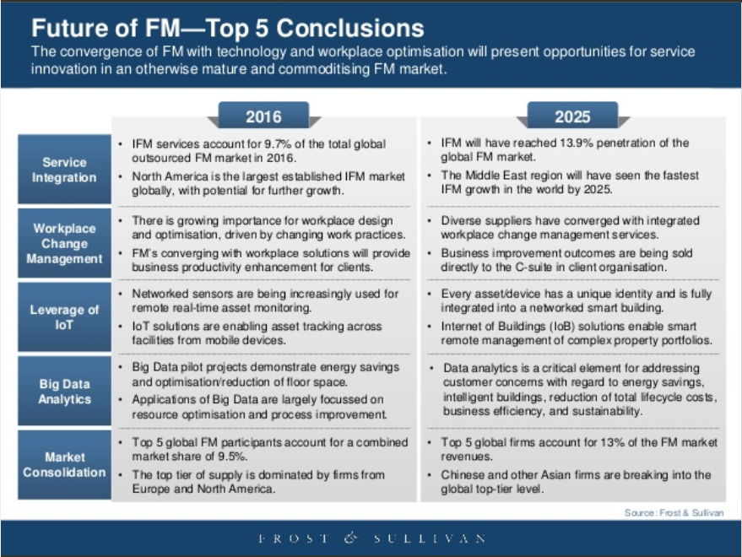

The facilities management in APC is operated manually by the Security Department. The basis for turning on and off certain facilities are the class schedules provided by the registrar’s office, and the reservations made through the reservation clerks and ITRO. In APC, they have five reservation clerks who are responsible for organizing the reservation by the reservee. The following are the responsibility of each reservation clerk:

|  |  |
| --- | --- |
| Reservation Clerk | Scope of Responsibility |
| Receptionist (4th floor) | Reservations on classrooms - both laboratories and lectures, auditorium, multi-purpose hall 1 and 2, parking, and basketball court made by members of APC. |
| ITRO (5th floor) | Computer laboratories. |
| Library (7th floor) | Discussion room B and C, Game Library, and Audio-Visual Room. |
| Engineering and Laboratory Sciences (8th floor) | Laboratories in the 8th floor, projects lab, and open lab |
| Building Administration (10th floor) | Reservations on classrooms - both laboratories and lectures, auditorium, multi-purpose hall 1 and 2, parking, and basketball court made by outsiders. |

Different protocols are made in different types of rooms and depending on the class schedules. It is made through the offerings of the courses or petitioned subjects that were later approved. These schedules are then forwarded to the receptionist by the registrar at the 4th floor and is taken by the Security Department for them to operate the facilities. However, there are instances when the location of the room is changed days or weeks after the official start of the classes. The Security Department is then notified about the changes by the receptionist at the 4th floor. These facilities are operated by what the Security Department identifies as Sky One and Sky Two. Sky One is in charge of ground floor up to 5th floor, Sky Two is in charge of the 6th up to 12th floor. Both of them fill in the job of the other if one is occupied. The air conditions are usually turned on 10 to 20 minutes before a class starts and is turned off and locked once the class is dismissed, but the rooms that don't have anything valuable such as projector and computers are left open in some cases. The usual cue for both Sky One and Sky Two is the presence of the professor. However, there are classrooms that have consecutive classes. These rooms are then left turned on regardless of whether the class is dismissed or not. Only classrooms that are unoccupied for more than two hours, early dismissal, no classes or reservations at all are turned off. The facilities are only turned on when the reservee, at the time of their reservation, tells the reservation clerk or Sky One or Sky Two to turn on the facilities and open the room that they have reserved. Reservations made that are not classrooms, except the basketball court, share the same protocol when turning on the facilities 10 to 20 minutes before an event starts as these rooms are huge and would require a longer amount of time to cool off.

Different reservations such as make-up classes event-related reservations can be made through the receptionist at the 4th floor or the building administration at the 10th depending on who the reservee is. In actuality, reservation for classrooms is usually handled by the receptionist at the 4th floor. While auditorium, basketball court, or any of the same room type are handled by the building administration. On the time of the said reservation, the reservee will be asked to present their reservation form for the room that they reserved. There is no formal place for the reservee and the Sky One or Sky Two to meet, but usually it is outside and of the time they reserved the room, and the number air conditioner that will be turned on will correspond to the number people that will use the room.

## Purpose and Description

APC is currently managing its facilities manually with the help of the Security Department. One of their main tasks is to turn on and off the air conditioners, lights, breaker, and computer, depending on the room type. However, this comes with a few drawbacks, considering the distance of one room to another, the number of the facilities and rooms they attend to, and the delay before the facilities must be turned off. Adding that up, the amount of electricity wasted would tantamount to the overall portion of the electricity bills of APC.

Not only that, the air conditioner is controlled through an infrared remote control that can be emulated using an infrared (IR) blaster. This device can be plugged in on a smartphone at its 3.5mm jack that is usually used for audio. With the help of an application, it can emulate the same frequencies sent by the original infrared remote control produced by the manufacturer. Therefore, enabling anyone to control the air conditioner unconditionally. In addition, turning off the air conditioners is not enough. The Security Department must make sure that the rooms are locked. Another account to the problem is the delay before Sky One or Sky Two unlocks the room and turns on the air conditioners, with the same causes of the delay in turning it off, this hinders the students to maximize the time provided in a class schedule. Depending on the room type, if the room has computers inside of it, the students are not allowed to enter until their professor is present and has the key, or if the professor is present but does not have the key and Sky One is present. If the room does not have computers in it, the students can go inside. However, usually with the air conditioners are usually turned off unless there was a class before it.

The facilities in the scheduled classes or reservations are to be turned on by Sky One or Sky Two a few minutes before the allotted time that by the registrar or reserved by the reservee and turned off in the following scenarios:

* No classes for the next two hours or more
* An early dismissal
* Professor is not present

However, APC's facility management continues to overthrow the extraordinary efforts made by the Security Department and facility owners due to the fact that there are cases when the air conditioners are left turned on even if there is no class in a room primarily because of Sky One and Sky Two are unaware that there has been an early dismissal or no classes at all. In cases that the room were left unlocked, usually because the room does not have a projector, students take advantage of an IR Blaster that can emulate an infrared remote control of the air condition.

With the implementation of an IoT enabled system, these inefficiencies can be avoided, by blocking the I/R receiver with a controller that corresponds to the deployment of schedules by the Registrar’s office, with the facilities being turned on when the class schedules start without having to wait for the roamers to turn on the facilities, and be turned off at the end of the class schedule.

## Objectives

The research is intended to help reduce the electricity consumption of APC by eliminating inefficient processes done by the Security Department through the implementation of an IoT solution. This research can be a contributory factor not only for APC, but also to other institutions of the same nature, as reducing the cost of electricity will be of help to any institution. According to Sir. Jojo Castillo, the Security Department is not really intended to operate the facilities of APC. Before, there were delegated personnel to accomplish such tasks, then it was transferred to the janitors. Since they kept losing the keys of the doors, it was transferred to the Security Department. That is now playing a huge role in reducing APC's electricity consumption.

#### General Objectives

* Implement an IoT solution that will control the facilities in a room, helping in lessening the overall electricity consumption of APC
* Improve the process involve in replacing defective facilities

#### Specific Objectives

* Implement an IoT solution to automatically operate the room’s lights, air condition and/or computers that is based on the deployment of class schedules by the registrar’s office to help reduce the electricity consumption used for such operation
* Implementation of a web-based reporting system – reported by the professors, to hasten the process of replacing defective facilities

## Scope and Limitations

This study is intended to provide an IoT solution for APC’s facilities management where the air conditioner, lights, and computers of the classrooms that will be automatically operated and monitored base on the schedules provided in the IoT device. All facilities that are not inside the classrooms will be not be covered by the IoT device. The operation of the facilities will only follow the class schedules provided by the registrar that is stored in APCIS. The content of the project will follow the client’s request and any suggestion will be immediately addressed.

# Related Literature

In this section, other projects related to the project “Internet of Things for Asia Pacific College’s Facility Management System” can be found here. The related projects that the group gathered to is not exactly alike to the group’s project since the projects that the groups have searched for focuses on a different device or output than the group’s project. However, the related project that the group gathered has the same concept and background.

The Internet of things (IoT) is now trending in the world since the things it can do opens other doors of discoveries in the world of technology. IoT is the network where physical devices can connect with one another like aircon, lights, coffee maker, and other items with electronics, software, sensors, actuators, and connectivity. The devices exchanges data in order to analyze and perform a certain event which makes things easier and organized. The sensors are the devices that receive and understand contextualized data in real-time depending on its specifications. With the help of sensors, it can add more of a building’s environment. Through iot, it upgrades the capabilities of building by making it more productive, resilient, and sustainable. With this, people could do more within a building. Employees can be more efficient.

## Meeting Room Monitoring

Tim Streather. 2016. IOT: Digital Disruption in Facilities Management. Retrieved from <https://www.avnet.com/wps/wcm/connect/onesite/72779a3b-1d08-42dc-a5ee-5e16bdf62922/SPICA-iot-management.pdf?MOD=AJPERES&CVID=lIwp6Q9&CVID=lIwp6Q9&CVID=lIwp6Q9&CVID=lIwp6Q9>, this program or system helps us meeting rooms effectively. With the use of sensors, the system can learn whether a room is occupied, or if the people that occupied it made a booking. It can estimate the number of people occupied in the room. The system also utilizes each room by analyzing the rooms through sensor data. With the use of this system, rooms are use properly and effectively. For example, it can detect if people are using the appropriate size meeting room for the number of participants or whether the room space is compatible with what the people are doing. The data acquired through this system can also be integrated provided by a BMS system to compare accuracy, and act as feedback loop to improve building controls.

## Konica Minolta Laboratory Europe (KMLE) Solution

Konicaminolta. 2015. Smart Room Booking System. Retrieved from <http://research.konicaminolta.eu/projects/smart-room-booking-system-kmle/>, according to KMLE Solution, they use a Smart Room Booking(SRB) system to detect or monitor rooms when being used or not by connecting to an intelligent calendar application. With this type of system the user can easily identify rooms that are available and use them for meetings or other purposes. The SRB system also falls to many systems that is built on the Internet of things. It also uses data from distributed sensors and combine it with machine learning to understand the user’s behavior and make improvements out of it. KMLE solution applies the machine learning to solve its common enterprise problems like its conflicts in booking for a room. This system helps optimize booking processes and shortens the reservation period. This helps employees to be more productive.

## Smart Meeting Rooms – Intel IoT

[xs2instructables](http://www.instructables.com/member/xs2instructables/). 2015. Smart Meeting Rooms(INTEL IOT). Retrieved from <https://www.acm.org/publications/authors/reference-formatting>, smart Meeting Rooms (INTEL IOT) is an iot (Internet of Things) device that identifies room availability in real-time by using motion detection and detecting light intensity in the room. The system provides an output of a status of a Conference room or Meeting room whether or not it is available in real-time, which helps employees or teams to plan their meetings effectively and optimize the use of meeting rooms. When the teams book a meeting room and they dont show up, the system would provide its status in real time declaring the room available which then will inform the other team and can then use it. The system in general shows efficient way of booking meeting rooms, utilizing the meeting rooms, and Optimizing the use of the meeting rooms.

## Conference Room Truth Serum

Prasantha Jayakody. 2015. Conference Room Truth Serum. Retrieved from <https://www.hackster.io/peejster/conference-room-truth-serum-434e7e>, the Conference Room Truth Serum is made by Prasantha Jayakody. The components being used are simple PIR motion sensor connected to a Rasberry Pi running Windows 10 Iot Core. This system can know if a meeting room is occupied or not regardless of the online schedule shown. According to Prasantha Jayakody, this system is not limited only to office or meeting room but could also be used by rooms in a house. Prasantha Jayakody explained that the project was made due to finding all the conference rooms being booked in the online scheduler, then after roaming around the building and finding out that some of the conference rooms were unoccupied. After finding out with Conference room monitor if the rooms are occupied or not then some employees like Prasantha Jayakody could use the unoccupied Conference Room for meeting and other purposes. The Conference Room Truth Serum system optimizes and utilizes the use of Conference rooms where employees could have more time being productive.

## Meeting Room Booking System (MBRS)

Jaorawala, Patole, Shaikh, Mehta, and Narayandasani. 2014. Meeting Room Booking System. Retrieved from: <https://www.arrkgroup.com/thought-leadership/prototyping-iot-to-link-bookings-with-meeting-room-door/>, the MRBS can be found at the Arrk Group office in India and this system can output the current and upcoming conference room bookings in real time where it is shown on the door of a conference room. The MRBS shows status of rooms that are booked and upcoming rooms that are booked which can help prevent conflict in bookings and efficiently book a meeting room

## Open Source Hassle-Free Booking System for Schools

Craig A Rodway. 2006. Open Source Hassle-free room booking system for schools. Retrieved from <https://classroombookings.com/>,

According to classroombooking.com the Open Source Hassle-free room booking system is an online booking system where bookings are made by one person for one room at a one-time period. All the bookings and the period that are marked as booked can be seen by other students which eliminates double booking. Administrators are also free to create a weekly timetable schedule and recurring bookings. The users are also free to assign a room each week to one of the timetable weeks which enable them to create schedules. The features presented in the web about the system are Eliminating double booking, Custom Timetable, Easy to use, and Cross-platform. These features are good for the room reservation system since it helps shorten the time for reservation and optimizes the way of reservation within a school.

## One Space

Redstone Connect. 2014. One Space Meeting Rooms. Retrieved from: <https://www.redstoneconnectplc.com/products/onespace/meeting-rooms/>, One space is a solution for meeting rooms management and it is fully-integrated solution that maximizes efficiency and usage for the employees. The system helps employees find available rooms for the employee’s use and work. It also shows the rooms needed by the employees like the size of the room and its facilities, so the one space is designed for the work of the employee. One space is accessible on mobile, web-interface, at reservation clerk, or make the reservation at the meeting room door display. The system includes external room booking, full financial control and cross charging management integrated with own accounting system if required. Based on the One Space activity, it helps utilize each room or workspace, and optimize the room reservation system by providing four ways in booking whether manual or automated. It also shortens the time spent on booking meeting rooms since each booking directly goes to the user’s calendar appointment.



## Synthesis

|  |  |  |  |  |  |  |  |
| --- | --- | --- | --- | --- | --- | --- | --- |
| ROOM RESERVATION SYSTEMS | AUTOMATED RESERVATION | MANUAL RESERVATION | PREVENTS BOOKING CONFLICTS | DISPLAYS CURRENT STATUS OF ROOM | DETECTS ROOM OCCUPENCY | IOT BASED | PROVIDES ANALYSIS REPORT |
| Meeting Room Monitoring | ✓ | ✕ | ✓ | ✓ | ✓ | ✓ | ✓ |
| KMLE Solution | ✓ | ✕ | ✓ | ✓ | ✓ | ✓ | ✓ |
| Smart Meeting Rooms - Intel IoT | ✓ | ✓ | ✓ | ✓ | ✓ | ✓ | ✕ |
| Conference Room Truth Serum | ✓ | ✕ | ✓ | ✓ | ✓ | ✓ | ✕ |
| Meeting Room Booking System (MRBS) | ✓ | ✕ | ✓ | ✓ | ✕ | ✓ | ✕ |
| Open Source Hassle-free Room Booking System for Schools | ✓ | ✕ | ✓ | ✓ | ✕ | ✕ | ✓ |
| One Space | ✓ | ✓ | ✓ | ✓ | ✕ | ✕ | ✓ |
| Proposed system | ✓ | ✓ | ✓ | ✓ | ✕ | ✓ | ✓ |

# Technical Background

This framework of different theorems will be the basis to provide a comprehensive understanding of smart buildings. Smart buildings are an integration of different features that a business needs that are usually designed to be self-sustaining, efficient in allocating resources, scalable and can provide information that can help implement reliable solutions. These buildings were designed to deliver services useful for the business and its customer while maintaining overhead at the lowest cost environment and prolonging the impact of the building lifecycle. The four corners of the room are constructed of interrelated embedded systems that fit the building's requirement. According to Building Efficiency Initiative, "smart buildings use information technology during operation to connect a variety of subsystems, which typically operate independently, so that these systems can share information to optimize total building performance". With all that, a smart building can be define as a system of interconnected subsystems that uses the power of the Internet to communicate with other subsystems to provide features that benefit the business.

## Facility Management

Sustainability, Facility Management and IFMA. (2012) Christopher P. Hodges. Retrieved from: <https://www.feapc.com/wp-content/uploads/2012/09/Facility-Fusion-IFMA-and-Sustainability.pdf>, currently, Facility Management or FM is "a profession that encompasses multiple disciplines to ensure functionality of the built environment by integrating people, place and technology". Throughout the years, the definition of different authors boiled down to one thing. FM maintains and operates the facilities to meet business needs, according to Rentokil, in the early 1970s, "FM started as little more than janitorial and caretaker services during the 1970s, involving building maintenance and cleaning". But since hiring your own maintenance crew can be quite expensive, businesses outsourced none-core services such as lightning, heating, plumbing to facility management companies. Years later, businesses found that with all the expansion and maintaining of the facilities, it can be utterly straining to the overall activities of the business since most of the activities related to such are done by different departments which is time costly and better be done by someone else. For businesses to focus on their actual business, different businesses adopted different methods, some businesses unified their maintenance crew so that communication can be more efficient, while other businesses outsourced their facilities management.

## Integrated Facility Management

A New Era of Service Integration, Energy Management, Business Productivity, Smart Technology, and Internationalisation. (2016) Frost & Sullivan. Retrieved from: <https://www.slideshare.net/FrostandSullivan/the-future-of-facility-management-research-preview>, it is the combination a of multitude of fields that work together in improving business operation that are non-core and core related to further improve the services rendered by the business. Different methods are adopted in integrated facility management, usually depending on the scale of the business, where they can outsource the all or partly the services of a facility management for them to be able to focus more on their actual business. Other businesses such as Oracle employed their own in house crew to maintain and expand their facilities and geographical location over the globe through the use of their proprietary "Unifier Facilities Management" that mainly focus on three areas, particularly maintenance, space, and conditional assessment, these features are then used to improve their decision making in events such as, purchasing equipment, maintaining equipment and fully utilizing those equipment. As for the space feature it keeps track of floor planning to manage every corner of the building such as, managing space request and assignments for employees, and keeping track of the volume of people in an area. Conditional Assessment is the feature that provide the analytics that provides information for different business needs.

## Internet of Things

M. Rouse, Unique Identifier (UID). Retrieved from <https://www.forbes.com/sites/blakemorgan/2016/01/27/5-easy-to-understand-examples-of-iot-and-costumer-experience/3/#28ab27a6c93>, it is a system of interrelated computing devices that are embedded with unique identifiers and has the ability to transfer data to a network without the need for human-to-human or human-to-computer interaction. Internet of Things (IoT) in general is a growing trend that is overlooked upon, many see this as a novelty product like PlayStation decades ago. However, with the current rate in development of technology and the growing demand for “smart” technologies – soon, everything will be right in front of us. The increase machine-to-machine (M2M) communication everything from street lights to cloud computing and networks of data-gathering sensors. It’s going to make everything in our lights “smart”. But it is not just referring strictly to M2M. IoT’s scope also covers sensor – for starters, sensor is not a machine, it doesn’t do anything in the same sense that a machine does. It is the integration of data and leveraging it – as all the information gathered by all the sensors in the world isn’t worth very much if there isn’t an infrastructure in place to analyze it in real time. With the help of cloud-based application, data that came from sensors can easily be interpreted and transmitted enabling the applications from PC to handheld devices to work anytime and anywhere. This technology is a revolution for facilities, imagine a simple air conditioner that collectively consumes a massive amount of energy and is operated through a web or software interface that is accompanied with sensors that detect movement and uses those movements to turn itself on. It also provides information for analytics at the same time. It can tremendously be a huge leap to the overall sustainability of every business' facilities management sustainability.

## Intelligent Enterprise

J.B Quinn, The Intelligent Enterprise a New Paradigm (1992) Retrieved from, https://www.jstor.org/stable/4165094?seq=1#page_scan_tab_contents "Intelligent Enterprise refers to a management approach that applies technology and new service paradigms to the challenge of improving business performance.” The concept of Intelligent enterprises is being shaped by the ever-growing technology. The first is the growing power of the computers and big data. This provide a multitude of methods for operations research such as forecasting, models, and Artificial Intelligence or AI. Second is the growth of our society that is farfetched of idea with judgment, reasoning, and choice. Different enterprises have now developed ways to improve their decision making through the help of big data and technology. People are now not just using products and services, but feeding information and access back to them. Intelligent Enterprise covers a wide array of fields where regulations, ecosystems, partnerships, ethics, and privacy are playing a huge role, as gathering big data is a challenge for businesses to have it completely legal and ethical as much as possible.

## Living Services

Through the conclusion provided by the appropriate analytics, businesses can establish a set of parameters to further improve their services and business' needs. Accenture, The Era of Living Services. Retrieved from https://www.accenture.com/t20160719T031357__w__/fi-en/_acnmedia/PDF-26/Accenture-The-Era-of-Living-Services.pdf, "Living Services respond by wrapping around us, constantly learning more about our needs, intents and preferences, so that they can flex and adapt to make themselves more relevant, engaging and useful. Consumers demand this now as the standards are being set by the best of breed across the entirety of their experiences, not restricted by sector—hence liquid expectations". Before, data gathering on customers was made through surveys, statistics, drop boxes in the office building or an online evaluation form, but this is usually disregarded by customers as they cannot be bothered by it, usually, feedback taken from customers are just rants about the services and/or product because people see it as a way to vent their dissatisfaction. But now data can now be gathered without the knowledge of the customer with the power of IoT, sensors and algorithms, embedded systems can gather different sets parameters that can be use to study the habits, likes and dislikes, and be tailored to customers liquid expectations. With the ultimate goal that is having to dynamically change in real time the response of the system to cater the customers' need and be able to render or provide the same service or product to the customer and/or user, if not better.

## IoT Big Data Platforms

E. Ahmed, I. Yaqoob, I. Hasem, I. Khan, The Role of Big Data Analytics in Internet of Things. Retrieved from http://www.diva-portal.org/smash/record.jsf?pid=diva2%3A1118022&dswid=-5434 , in their research "The Role of Big Data Analytics in Internet of Things", "the explosive growth in the number of devices connected to the Internet of Things and the exponential increase in data consumption only reflect how the growth of big data perfectly overlaps with that of IoT", however, if without proper management, data gathered is left for naught. According to Gartner, "the revenue that is generated from IoT-enabled services and products will exceed $300 billion by 2020", but in turn, the increase of data gathered of IoT-enabled services is going to vast - which will force companies to upgrade their current system for gathering such volumes. To keep up with the so called "third wave of the internet", first thing that these IoT-enabled services companies have to consider is to upgrade their data storage framework just to handle the vast load of data, one alternative to that is migrating towards the Platform-as-a-Service or PAAS model, it is a cloud based solution, that instead of maintaining your down data storage framework, PAAS can provide the same service but with flexibility, scalability, compliance, cost-effective, secure, and an established architecture to store such data, unlike an in-house data storage framework where it is not beneficial as the former, but the disadvantage is the reliance to a to an outsourced service.

## Machine Learning

Brilliant.org. Retrieved from <https://brilliant.org/wiki/machine-learning/>. Machine Learning or ML, "is a cutting-edge field in computer science that seeks to get computers to carry out tasks without being explicitly programmed to carry out a given task. Machine learning uses many techniques to create algorithms to learn and make predictions from data sets". Machine Learning is known for data mining that repeatedly iterates itself for millions or billions of times depending on the number of variables to discover new patterns and models and add that to its previous self. To discover these patterns, Machine Learning is first build from a training set that is input into an algorithm where different variables are already known, different variables are then combined/separated and stored in to parameters and those parameters are then used for reading the input and predicting the output. Different methodologies are used to create a Machine Learning program, depending on what is to be processed, these methods can be beneficial if used correctly:

Supervised Learning is use when the algorithm needs to learn new mapping example. An example of such would be the CAPTCHA wherein it is used to prevent spams. Before, CAPTCHA we're only a combination of numbers and letters on a picture that a user must read to and input it for the server to identify if the user is an actual person. Unfortunately, bots are able to bypass CAPTCHA that is why it was changed to a set of pictures that a user has to identify, based on the category that is being required.

Unlike supervised learning where data is labeled, unsupervised learning uses input data that is unlabeled, meaning there is only input data without parallel output data. According to Jason Brownlee, "These are called unsupervised learning because unlike supervised learning above there is no correct answers and there is no teacher. Algorithms are left to their own devises to discover and present the interesting structure in the data". The idea behind unsupervised learning is for the Machine Learning to understand the underlying patterns in the data set provided.

## Artificial Intelligence

Artificial Intelligence or AI is seen to be the same as Machine Learning where in fact, Machine Learning is just a subset of AI. AI uses Machine Learning as a basis for its decision making. An AI is called AI when it can make decisions and learn by itself. Britannica. Retrieved from <https://www.britannica.com/technology/artificial-intelligence>, it is "the ability of a digital computer or computer-controlled robot to perform tasks commonly associated with intelligent beings.” Different aspects are considered in developing an AI such as learning, reasoning, problem solving, perception and language. As human beings we learn from different things, from the way we see to the way we perceive. One of the simplest forms of learning is by trial and error, where an input corresponds to an immediate output. Reasoning is through logic and common sense. We perceive things through inferences to different situations that we encounter. Problem solving is one of the major challenges in AI, an AI cannot think for itself and it cannot suggest creative ideas, but procedural problem solving is what at most an AI can do, this is gained from the learning different sets of patterns to arrive at the right answer. Perception is how an AI perceive its environment, as humans we perceive the world through our senses, and we interpret it base on what we know at the moment, currently, artificial perception is already advance as it is - enabling optical sensors to identify objects and respond to it. Language for an AI is neither the language that we speak or how it is made, but it is the ability to communicate the inputs it has taken.

## Signal Processing

IEEE Signal Processing Society. Retrieved from <https://signalprocessingsociety.org/>, "Signal Processing is a branch of electrical engineering which pulls meaning from the broad sources of data that are all around us.” These signals gathered are then used to convey information about the pattern of different phenomena. It covers all the things that operates the modern world such as voice recognition, motion-sensing gaming, autonomous vehicles, biometric security and computer interfaces. Major categories of signal processing are continuous-time signal processing and discrete-time signal processing that are under analog signal processing and digital signal processing. An analog signal processing are signals that are not digitized such as radios, telephone, and some television systems. Continuous-time signal processing is a type of analog signal that may not be finite, such as signals from pressure, temperature, and sound. Discrete-time signal processing is another type of analog signal that uses a period from a continuous signal as sample. Digital signal processing is the use of digital processing to perform a wide variety of signal processing operations in domain such as time, space, or frequency.

## Cognitive Computing

Cognitive computing encompasses some parts of AI and different areas of signal processing. Due to being broad, different authors defined cognitive computing in multiple ways that some encompass the other definition. B. Marr. Cognitive Computing Demystified: The What, Why, and How. Retrieved from http://www.dataversity.net/cognitive-computing-the-what-why-and-how/, provides a clear definition of cognitive computing, "The goal of cognitive computing is to simulate human thought processes in a computerized model. Using self-learning algorithms that use data mining, pattern recognition and natural language processing, the computer can mimic the way the human brain works.” Cognitive computing is intended to enable machines to interact with humans in a more natural way. This technology creates a clear map to make rational business conclusions from the right set of data to make a reliable set of solutions. Through different inputs from user feedback, big and new data, and related experience, cognitive systems can become experts in specific areas making it a perfect companion to existing human expertise.

# Design and Methodology

## Requirements Analysis

## Event Table

|  |  |  |  |  |  |
| --- | --- | --- | --- | --- | --- |
| Event | Trigger | Source | Use Case | Response | Destination |
| Provide Class Schedules. | Start of a New Term. | APCIS | Provide Updated Class Schedules. | Class Schedule Details. | FACILITY |
| Operation of facilities. | Class Schedules. | FACILITY | Checks Class Schedule Details. | Process Class Schedule Details. | APCIS |
| Professor reserves additional facility. | Professor reserved additional facility. | PROFESSOR | Reserve additional facility. | Record reservation. | APCIS |
| Activate Facility X  Amount of Minutes  Before Class Starts | Based on Class Schedules. | APCIS | Activates the facilities in a room. | Air conditioner, lights, and/or computers are turned on or off based on the time allocated. | FACILITY |
| Deactivates the air conditioner, lights and/or computers. | Turning off Facilities in the event that:   * Professor is absent * Class is dismissed * Early dismissal * Class suspension   After the X number of minutes that the sensors had not detected any movement in a room. | APCIS | Deactivates facilities in a room. | Air conditioner, lights, and/or computers are turned off. | FACILITY |
| Facility sends feedback. | The time facilities are turned on and/or off. | FACILITY | Process feedback. | Provide reports based on the feedback. | APCIS |
| Both professor reports and processed feedback are consolidated. | Received professor reported state of facility and/or feedback from facility. | PROFESSOR | Report facility details. | Process Report | APCIS |

## Requirements Documentation

## Use Case Full Description

## Provide class schedules

|  |  |  |
| --- | --- | --- |
| Use Case Name: | Provide Updated Class Schedules. | |
| Scenario: | Provide Class Schedules. | |
| Triggering Event: | Start of a New Term. | |
| Brief Description: | To provide the updated class schedules resulting from merging, dissolution and petitioned courses and latest courses for the new term. | |
| Actors: | FACILITY and APCIS. | |
| Related Use Case: | * Checks Class Schedule Details | |
| Stakeholders: | Registrar. | |
| Preconditions: | A new term has started and/or the merging, dissolution and petitioned are consummated. | |
| Post Conditions: | System is provided with the latest and/or updated set of class schedules. | |
| Assumptions: | Class schedule provided is for the current term. | |
| Flow of Activities: | Registrar | APCIS |
| 1.0 Deploys new sets of class schedules | 2.0 Stores new sets of class schedules |
| Exception Conditions: | * No new sets of class schedules. | |

## Operation of facilities

|  |  |  |
| --- | --- | --- |
| Use Case Name: | Checks Class Schedule Details. | |
| Scenario: | Operation of Facilities. | |
| Triggering Event: | Class Schedules. | |
| Brief Description: | Facility Management System checks the class schedules stored in APCIS to operate the facilities. | |
| Actors: | FACILITY and APCIS. | |
| Related Use Case: | * Activates the facilities in a room * Deactivates facilities in a room * Process feedback | |
| Stakeholders: | ITRO. | |
| Preconditions: | A set of class schedules has been provided. | |
| Post Conditions: | System will operate the facilities based on the set of class schedules provided. | |
| Assumptions: | Class schedule provided is updated. | |
| Flow of Activities: | APCIS | Facility |
| 1.0 Provides sets of class schedules | 2.0Checks class schedule provided by APCIS |
| Exception Conditions: | * Suspension of classes. | |

## 

## Professor reserves an additional facility

|  |  |  |
| --- | --- | --- |
| Use Case Name: | Reserve additional facility. | |
| Scenario: | Professor reserves an additional facility | |
| Triggering Event: | Professor reserved additional facility. | |
| Brief Description: | Professor request a new facility | |
| Actors: | PROFESSOR and APCIS. | |
| Related Use Case: | * Activates facilities in a room * Deactivates facilities in a room * Checks Class Schedule Detail | |
| Stakeholders: | PROFESSORS | |
| Preconditions: | Operation of facilities | |
| Post Conditions: | A new facility was provided. | |
| Assumptions: | * Additional facility was requested because the current on is broken | |
| Flow of Activities: | Professor | APCIS |
| 1.0 Professor reserved a new facility | 2.0 A new facility was provided |
| Exception Conditions: | * All the facilities in the room are working * Not in need of another facility | |

## Activates the facilities in a room

|  |  |  |
| --- | --- | --- |
| Use Case Name: | Activates the Facilities in a room. | |
| Scenario: | Activate Facility X Amount of Minutes Before Class Starts. | |
| Triggering Event: | Based on Class Schedules. | |
| Brief Description: | Activates the facilities in a room based on the class schedule provided by APCIS. | |
| Actors: | FACILITY and APCIS. | |
| Related Use Case: | * Checks Class Schedule Details * Deactivates facilities in a room * Process feedback | |
| Stakeholders: | ITRO. | |
| Preconditions: | On the current time and given timeslot, there is a class. | |
| Post Conditions: | Lights, air condition and/or computers are activated. | |
| Assumptions: | There is a class on the current timeslot. | |
| Flow of Activities: | APCIS | Facility |
| 1. Provides sets of class schedules | 1. Checks class schedule provided by APCIS |
| Exception Conditions: | * No classes for the given timeslot * Suspension of classes | |

## Deactivates the air conditioner, lights, computers, and projectors

|  |  |  |
| --- | --- | --- |
| Use Case Name: | Deactivates facilities in a room. | |
| Scenario: | Deactivates the air conditioner, lights, computers, and projector. | |
| Triggering Event: | Turning off Facilities if:   * Professor is absent * Class is dismissed * Early dismissal | |
| Brief Description: | Deactivates the facilities in a room based on the class schedule provided by APCIS. | |
| Actors: | FACILITY and APCIS. | |
| Related Use Case: | * Checks Class Schedule Details * Activates facilities in a room * Process feedback | |
| Stakeholders: | Registrar and ITRO. | |
| Preconditions: | After the X number of minutes that the sensors had not detected any movement in a room. | |
| Post Conditions: | Lights, air condition and/or computers are deactivated. | |
| Assumptions: | * Professor is absent * Class is dismissed * Early dismissal * Class suspension | |
| Flow of Activities: | APCIS | Facility |
| 1.0 Provides sets of class schedules | 2.0 Checks class schedule provided by APCIS and other preconditions |
| Exception Conditions: | * Class is ongoing * Professor is present for the current timeslot * No suspension of classes | |

## Facility sends feedback

|  |  |  |
| --- | --- | --- |
| Use Case Name: | Process Feedback. | |
| Scenario: | Facility Sends Feedback. | |
| Triggering Event: | The time facilities are turned on and/or off. | |
| Brief Description: | System provides feedback base on the behavior of the facility. | |
| Actors: | FACILITY and APCIS. | |
| Related Use Case: | * Checks Class Schedule Details * Activates facilities in a room * Deactivates facilities in a room | |
| Stakeholders: | ITRO. | |
| Preconditions: | Operation of Facilities. | |
| Post Conditions: | Process feedback provided by the facilities. | |
| Assumptions: | Facility was either turned on or off. | |
| Flow of Activities: | APCIS | Facility |
| 1.0 Provides sets of class schedules | 2.0 Provides feedback base on its operation |
| Exception Conditions: | * No suspension of classes | |

## Deployment of New Class Schedules

|  |  |  |
| --- | --- | --- |
| Use Case Name: | Process Report | |
| Scenario: | Both professor reports and processed feedback are consolidated. | |
| Triggering Event: | Received professor reported state of facility and/or feedback from facility. | |
| Brief Description: | Professor reports about the state of the facility and is processed together with the facilities’ feedback. | |
| Actors: | PROFESSOR and APCIS. | |
| Related Use Case: | * Process Feedback * Activates facilities in a room * Deactivates facilities in a room | |
| Stakeholders: | PROFESSORS and ITRO. | |
| Preconditions: | Operation of facilities. | |
| Post Conditions: | Feedback and report if any, is processed | |
| Assumptions: | * Facility is operating * A faulty facility in a room | |
| Flow of Activities: | Professor | APCIS |
| 1. Uses facility 2. Reports faulty facility, if any | 3.0 Assess the report |
| Exception Conditions: | * No suspension of classes | |

## Gap Analysis/Needs Assessment

|  |  |  |  |
| --- | --- | --- | --- |
| Strategic Objective | Current Standing | Deficiency | Action Plan |
| The facilities are turned on minutes before the class or event starts. | Sky One or Sky Two turns on and the facilities manually based on class schedules and reservations that most of the time delayed. | Hindering the students to utilize the time provided by the course. | Implementation of an IoT device that is placed on fused and on the IR receiver of the air conditioner to turn on such without any manpower. |
| The facilities are turned off in the event:   * That there is no class * Early dismissal * Professor is not present * Suspension of classes | Sky One or Sky Two turns off the facilities manually that is most of the time inaccurate. | Failure to turn off facilities on time. Underutilized usage of facilities resulting to increase in utilities and depreciation expense. | The receptionist addresses to Sky One or Sky Two that there is no class, an early dismissal, or the professor is not present. |
| Broken facilities are replaced or fixed as soon as possible. | Broken facilities are only replaced or fixed when noticed. | Broken facilities are usually left ignored when left unused. | Have the professor report the defective facilities to offices in charge. |

## Design of Software, Systems, Product, and/or Processes

## Login Page

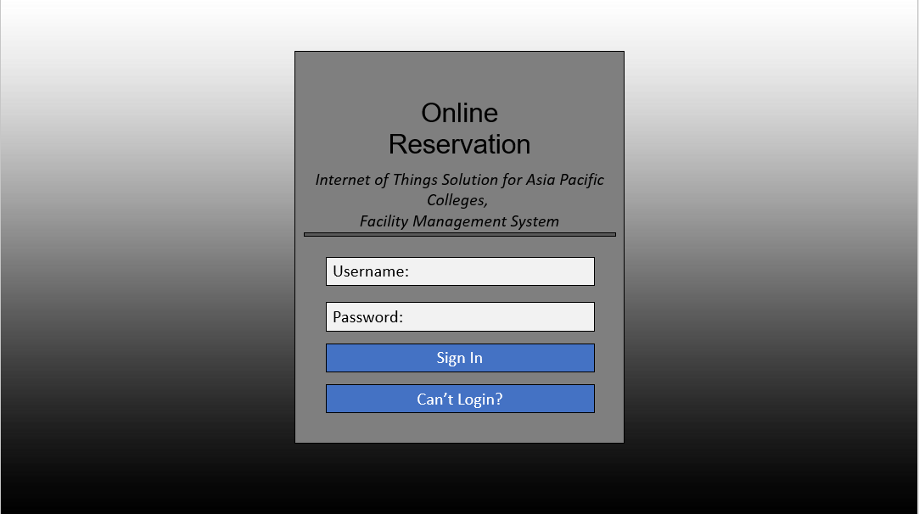

## Home Page

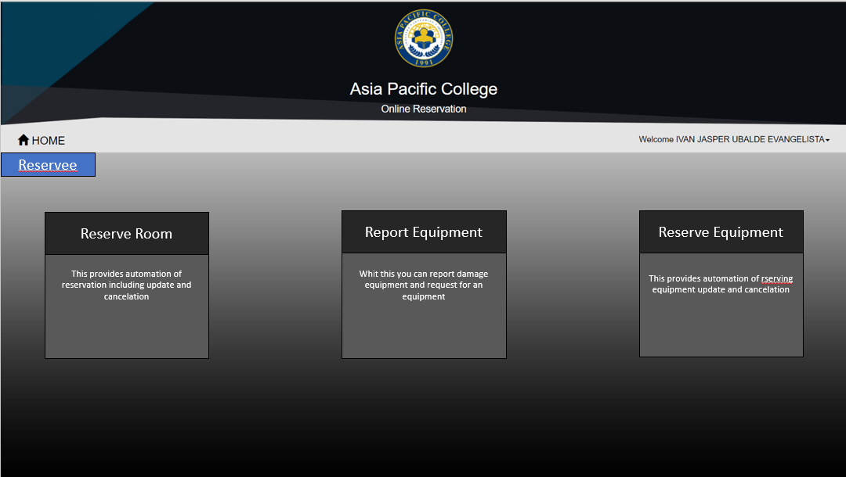

## Create Report

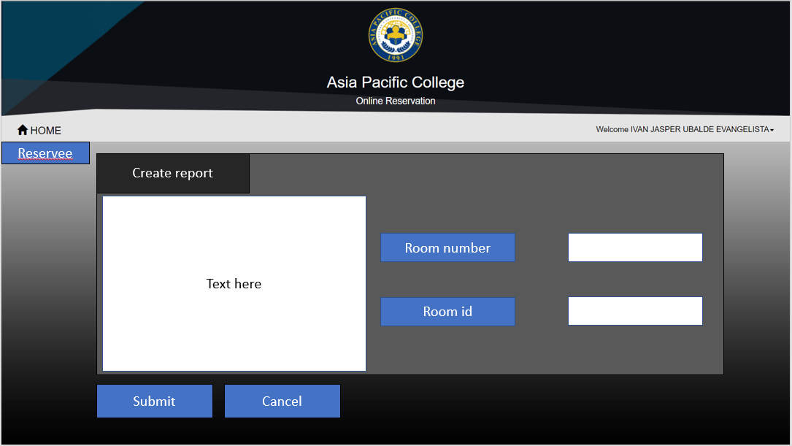

## Reserve Equipment

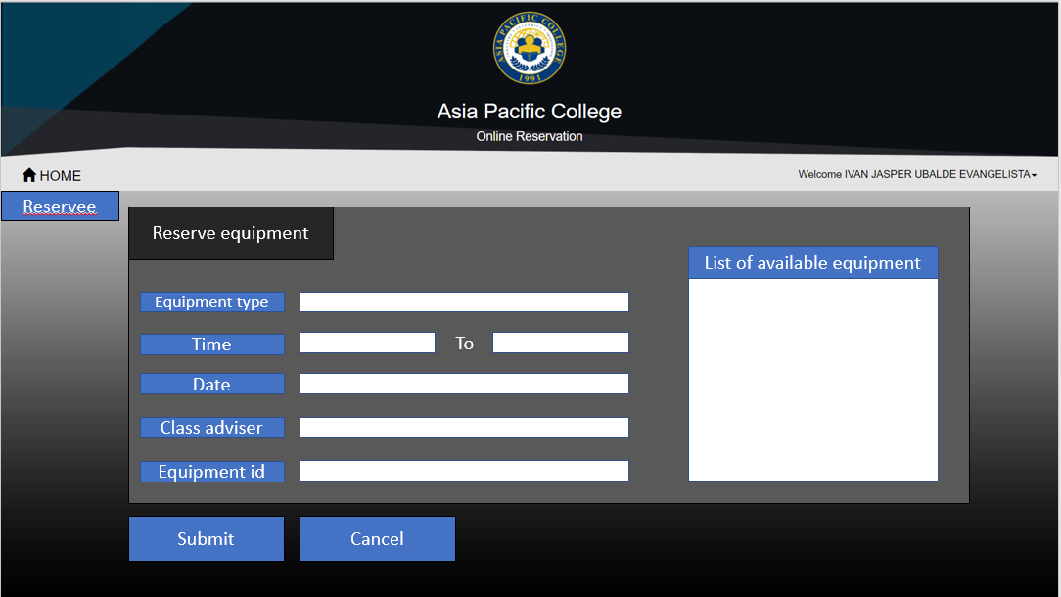

## Admin User

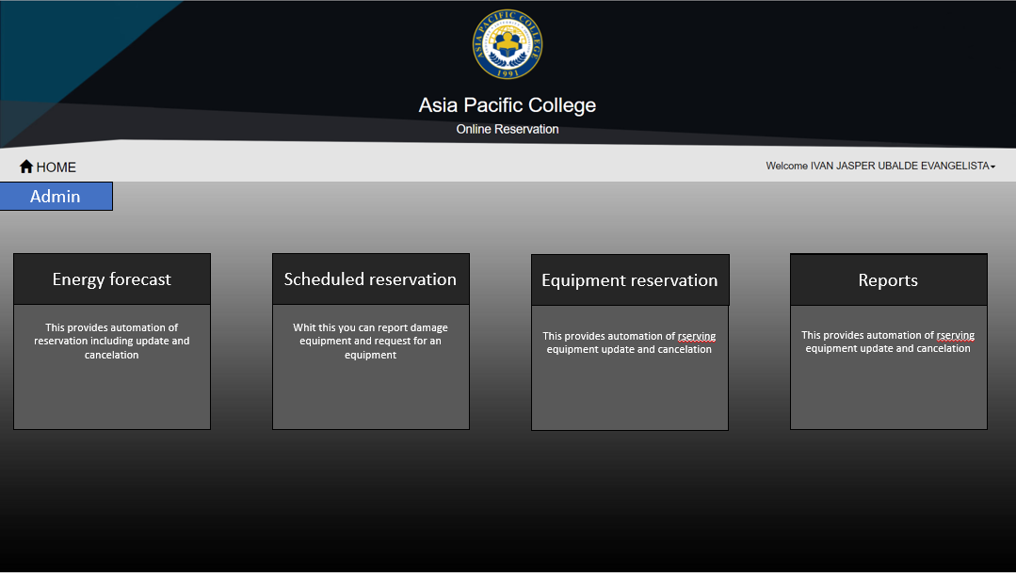

## Sample Layout of IOT

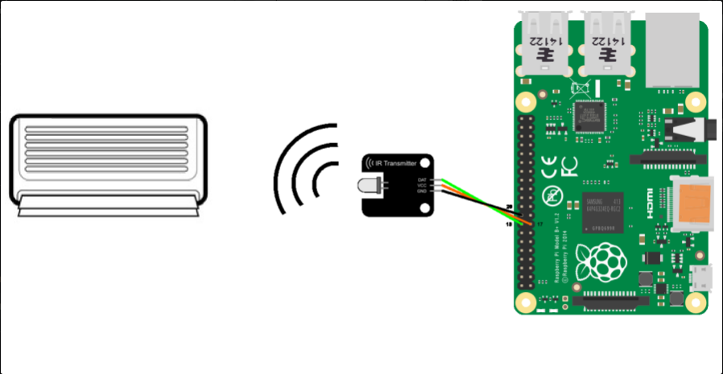

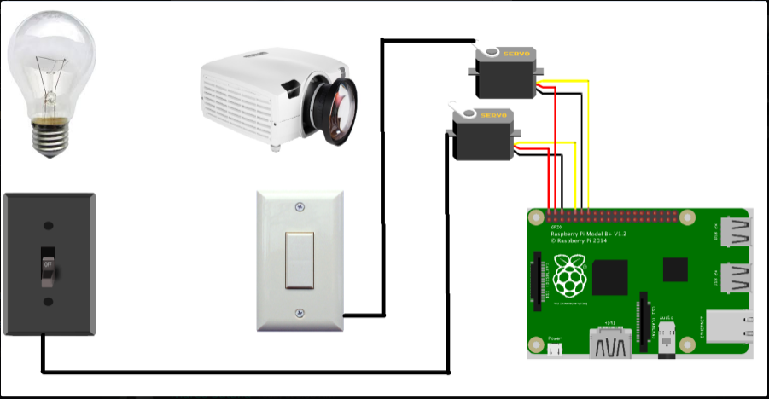

## Development and Testing, where applicable

In the development of the project, the group used Raspberry Pi 3 as a microcontroller to test the project. At first, the group opted for a NodeMCU ESP8266 microcontroller, but then the documentations only for such is inconsistent with the actual pinouts. Which made the group decide to go for a Raspberry Pi, considering its long history and documentation, we found that we would waste less time on troubleshooting with a Raspberry Pi 3 rather than ESP8266. The group used Raspbian as the operating system of the microcontroller, MySQL for the database, python to program the prototype and a LED that will represent as an output for the internal processes made by the microcontroller. For now, the group focused more on the input and process. The next phase would be the output phase - when different conditions are considered in testing the prototype.

## Description of the Prototype, where applicable

The project will make use of the class schedules provided by the registrar’s office that is stored in APCIS that will be used by the microcontroller to operate the facilities inside a room. Raspbian Jessie will serve as the backbone of the microcontroller, it is a Debian-based computer operating system for Raspberry Pi. The class schedules are deployed to the microcontroller’s database server that is MySQL and Python is used to program. Ideally, the deployment of the database in the microcontroller isn’t necessary, instead what will happen is the Raspberry Pi will serve as a client to the server hosting the database. That way, if ever there are changes in schedule, it will immediately reflect on the client’s side without having to redeploy the database again. On the Raspberry Pi 3, different modules will be connected specific for each type of room. The movement of the modules will be the output of the process. These modules are servo motors, and an IR transmitter, both will be used to operate the lights and air conditioner respectively.

## 4.7 Implementation Plan (Infrastructure/Deployment) where needed

The project will serve as a module and will operate base on the deployment of the class schedules provided by APCIS. Each room will have Raspberry Pi 3 to operate the facilities, servo motors will be used to operate the facilities with switches, for the light switch, the servo motor will be placed on top of it, same with the fuse. IR transmitter will be placed on top of the IR receiver of the air conditioner, blocking any interference for any IR blasters used by students.

## 

## Implementation Results, where applicable

## 4.9 Include discussion on conceptual design/system architecture/ block diagrams and algorithms

# Results and Discussion

# Conclusions and Recommendations

# Appendices

## Use Case Diagram

## C:\Users\JM\AppData\Local\Microsoft\Windows\INetCache\Content.Word\Use Case.pngOperation of facility

## C:\Users\JM\AppData\Local\Microsoft\Windows\INetCache\Content.Word\Use Case Professor.pngReporting and/or reservation of a facility by professor

## Context Diagram

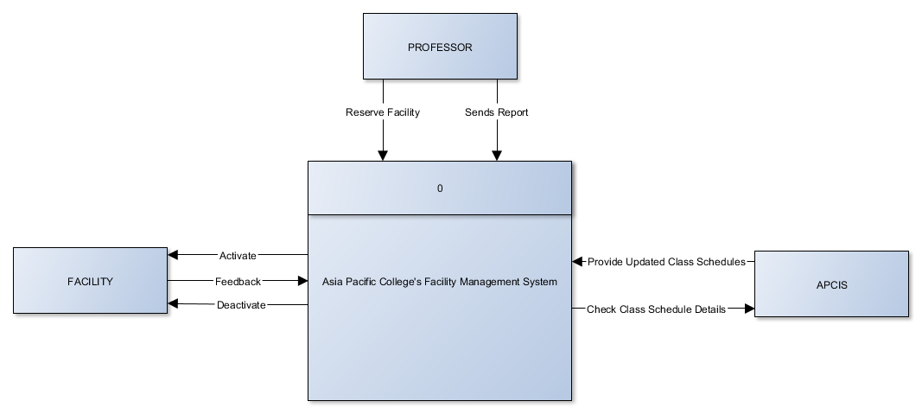

## Data Flow Diagram Level 0

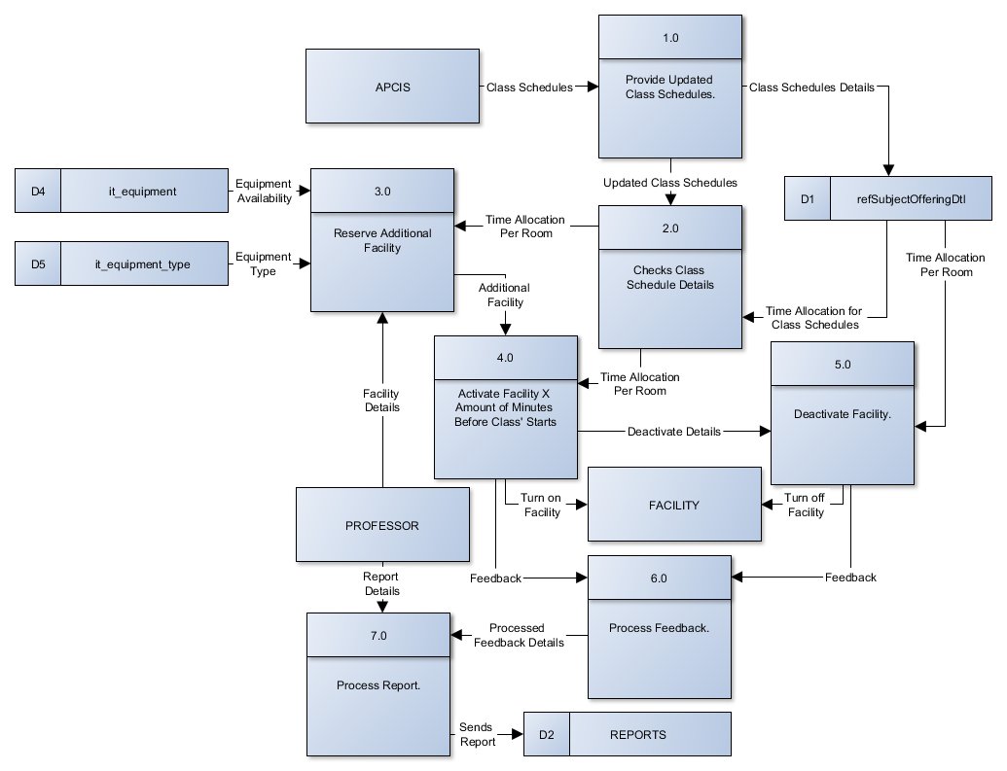

## Data Flow Diagram Level 1

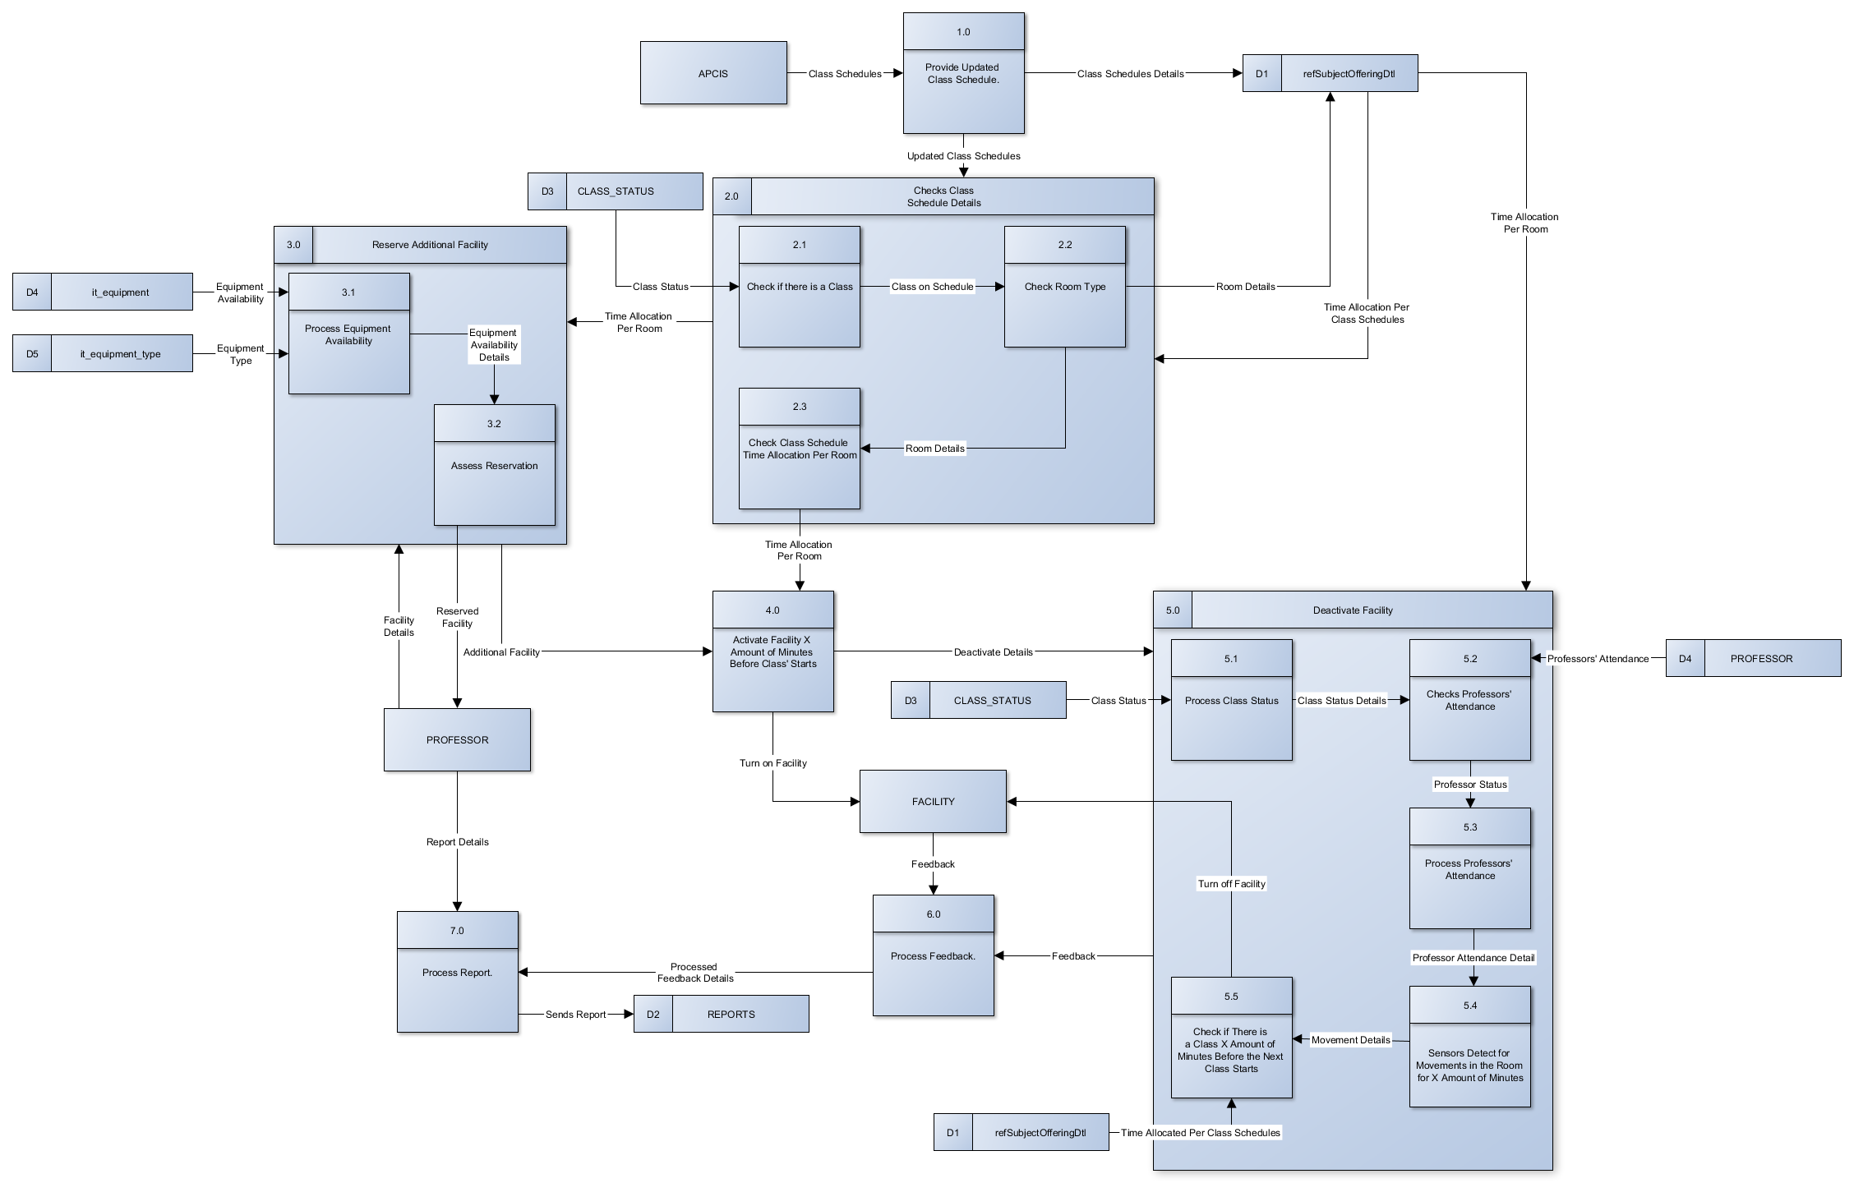

## Entity Relationship Diagram

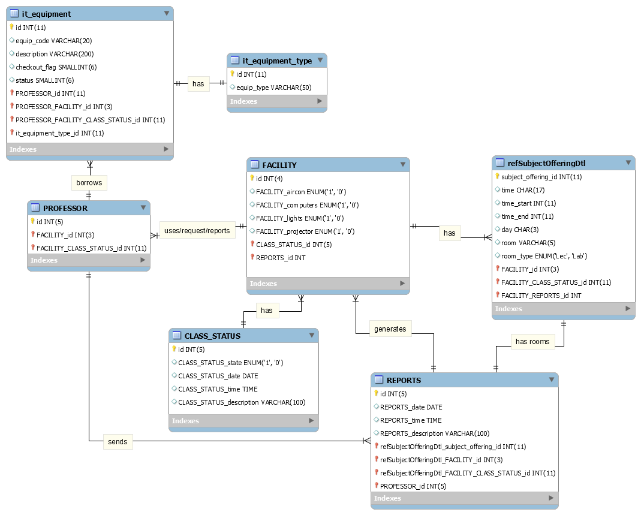

## Data Dictionary

## it_equipment

|  |  |  |  |  |  |  |  |
| --- | --- | --- | --- | --- | --- | --- | --- |
| Attribute Name | Contents | Type | Format | Range | Required | PK or FK | FK Referenced Table |
| Id | Unique identifier of it_equipment | Numeric(11) | 99999999999 | 0-99999999999 | Y | PK |  |
| equip_code | Code of equipment | VARCHAR(50) | Sample text here | 50 characters | Y |  |  |
| description | Remarks on reservation | TEXT | Sample text here | 65,535 characters | Y |  |  |
| Checkout_flag |  | SMALLINT(6) |  |  | Y |  |  |
| status | Status of reservation | Numeric(3) |  |  | Y |  |  |
| PROFESSOR_id | Unique identifier of  PROFESSOR | Numeric(11) | 99999999999 | 0-99999999999 | Y | FK | PROFESSOR |
| PROFESSOR_ FACILITY_id | Unique identifier of PROFESSOR | Numeric(3) | 999 | 0-999 | Y | FK | PROFESSOR |
| PROFESSOR_ FACILITY_ CLASS_ STATUS_id | Unique identifier of PROFESSOR | Numeric(11) | 99999999999 | 0-99999999999 | Y | FK | PROFESSOR |
| it_equipment_ type_id | Unique identifier of it_equipment_  type | Numeric(11) | 99999999999 | 0-99999999999 | Y | FK | It_equipment_ type |

## it_equipment_type

|  |  |  |  |  |  |  |  |
| --- | --- | --- | --- | --- | --- | --- | --- |
| Attribute Name | Contents | Type | Format | Range | Required | PK or FK | FK Referenced Table |
| id | Unique identifier of it_equipment_  type | Numeric(1) | 99999999999 | 0-99999999999 | Y | PK |  |
| equip_type | Type of equipment | VARCHAR(50) | Sample text here. | 50 Characters | Y |  |  |

## PROFESSOR

|  |  |  |  |  |  |  |  |
| --- | --- | --- | --- | --- | --- | --- | --- |
| Attribute Name | Contents | Type | Format | Range | Required | PK or FK | FK Referenced Table |
| id | Unique identifier of PROFESSOR. | NUMERIC(11) | 99999999999 | 0-99999999999 | Y | PK |  |
| FACILITY_id | Unique identifier of FACILITY. | Numeric(3) | 999 | 0-999 | Y | FK | FACILITY |
| FACILITY_ CLASS_ STATUS_ id | Unique identifier of CLASS_ STATUS | Numeric(11) | 99999999999 | 0-99999999999 | Y | FK | FACILITY |

## refSubjectOfferingDtl

|  |  |  |  |  |  |  |  |
| --- | --- | --- | --- | --- | --- | --- | --- |
| Attribute Name | Contents | Type | Format | Range | Required | PK or FK | FK Referenced Table |
| subject_offering_id | Unique identifier of refSubjectOfferingDtl. | NUMERIC(11) | 99999999999 | 1-99999999999 | Y | PK |  |
| time | To display the time format. | CHAR(17) | Sample text here. | 17 Characters. | N |  |  |
| time_start | Starting time of regular class schedule of the course. | NUMERIC(11) | 99999999999 | 1-99999999999 | Y |  |  |
| time_end | Ending time of regular class schedule of the course. | NUMERIC(11) | 99999999999 | 1-99999999999 | Y |  |  |
| day | Day/s of the week the course takes place. | NUMERIC(11) | 99999999999 | 1-99999999999 | N |  |  |
| room | Location of the room. | VARCHAR(5) | Sample text here. | 5 Characters. | Y |  |  |
| room_type | Type of the room, either lecture or laboratory. | ENUM | 'Lec', 'Lab' | 2 Constraints. | Y |  |  |

## FACILITY

|  |  |  |  |  |  |  |  |
| --- | --- | --- | --- | --- | --- | --- | --- |
| Attribute Name | Contents | Type | Format | Range | Required | PK or FK | FK Referenced Table |
| id | Unique identifier of FACILITY | Numeric(4) | 9999 | 0-9999 | Y | PK |  |
| FACILITY_aircon | Turn on = 1, Turn off = 0 | ENUM | 0 or 1 | 1 Character | Y |  |  |
| FACILITY_computers | Turn on = 1, Turn off = 0 | ENUM | 0 or 1 | 1 Character | N |  |  |
| FACILITY_lights | Turn on = 1, Turn off = 0 | ENUM | 0 or 1 | 1 Character | Y |  |  |
| FACILITY_projector | Turn on = 1, Turn off = 0 | ENUM | 0 or 1 | 1 Character | Y |  |  |
| CLASS_STATUS_id | Unique indentifier of CLASS_  STATUS_  id | Numeric(5) | 99999 | 0-99999 | Y | FK | CLASS_  STATUS |
| REPORTS_id | Unique identifier of REPORTS | Numeric(5) | 99999 | 0-99999 | Y | FK | REPORTS |

## CLASS_STATUS

|  |  |  |  |  |  |  |  |
| --- | --- | --- | --- | --- | --- | --- | --- |
| Attribute Name | Contents | Type | Format | Range | Required | PK or FK | FK Referenced Table |
| id | Unique identifier of CLASS_STATUS | Numeric(5) | 99999 | 0-99999 | Y | PK |  |
| CLASS_ STATUS_state | Status of classes, whether there is a class or none. | ENUM | 0 or 1 | 1 Character | Y |  |  |
| CLASS_ STATUS_date | Date of class status. | DATE | ‘YYYY-MM-DD’ | '1000-01-01' to '9999-12-31' | Y |  |  |
| CLASS_ STATUS_time | Time of suspension. | TIME | ‘HH:MM:SS’ | ‘00:00:00’ to ‘23:59:59' | N |  |  |
| CLASS_ STATUS_  description | Description of suspension. | VARCHAR  (100) | Sample text here. | 100 Characters | N |  |  |

## REPORTS

|  |  |  |  |  |  |  |  |
| --- | --- | --- | --- | --- | --- | --- | --- |
| Attribute Name | Contents | Type | Format | Range | Required | PK or FK | FK Referenced Table |
| id | Unique identifier of REPORTS. | Numeric(5) | 99999 | 0-99999 | Y | PK |  |
| REPORTS_date | Date of report. | DATE | ‘YYYY-MM-DD’ | '1000-01-01' to '9999-12-31' | Y |  |  |
| REPORTS_time | Time of report. | TIME | ‘HH:MM:SS’ | ‘00:00:00’ to ‘23:59:59' | Y |  |  |
| REPORTS_description | Description of report. | VARCHAR(100) | Sample text here. | 100 Characters. | Y |  |  |
| refSubjectOfferingDtl_subject_offering_id | Unique identifier of refSubjectOfferingDtl. | NUMERIC(11) | 99999999999 | 0-99999999999 | Y | FK | refSubjectOffering_id |
| refSubjectOfferingDtl_FACILITY_CLASS_STATUS_id | Unique identifier of CLASS_STATUS. | NUMERIC(11) | 99999999999 | 0-99999999999 | Y | FK | FACILITY |
| PROFESSOR_id | Unique identifier of PROFESSOR. | NUMERIC(11) | 99999999999 | 0-99999999999 | Y | FK | PROFESSOR |
| PROFESSOR_FACILITY_id | Unique identifier of FACILITY. | NUMERIC(3) | 999 | 0-999 | Y | FK | PROFESSOR |

## Activity Diagram

## Facility Management System

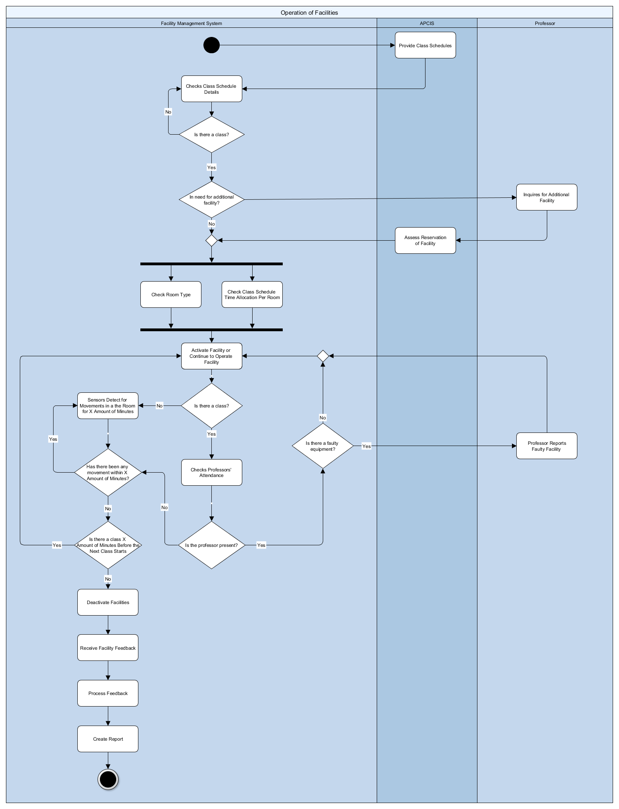

## System Sequence Diagram

## Operation of facilities

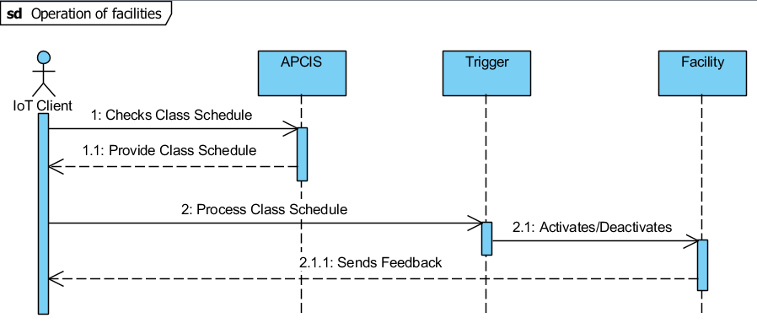

## Professor’s report

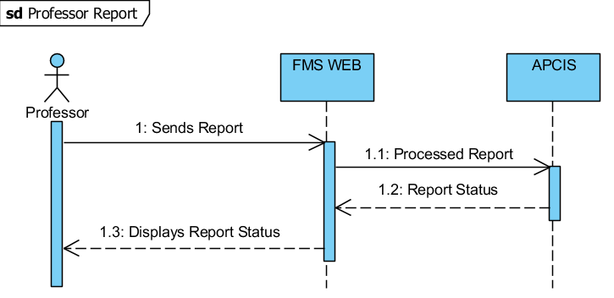

## Professor’s reservation

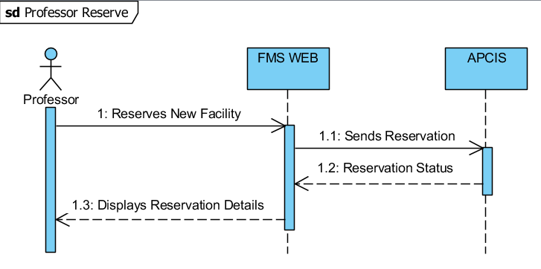

## Object Diagram

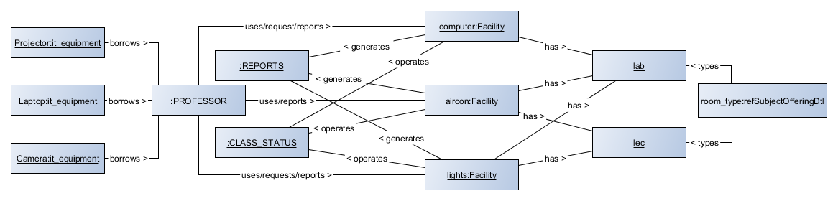

## Class Diagram

